Rose Garden [C]

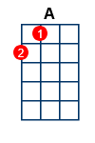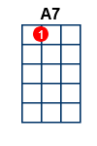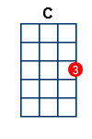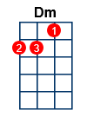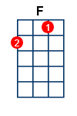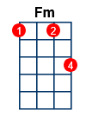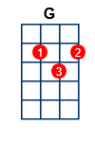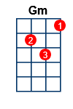
5 Chords:
[C]* [NC] I beg your [Dm] pardon [G] I never promised you a [C] rose garden Along with the [Dm] sunshine [G] there's gotta be a little [C] rain sometime When you [F] take you gotta give so live and let live or let [Dm] go oh oh oh [F] oh I beg your [G] pardon I never promised you a [C] rose garden
I could [C] promise you things like big diamond rings But you don't find roses growin' on stalks of [Dm] clover So you better think it [G] over Well, if [C] sweet talking you could make it come true I would give you the world right now on a silver [Dm] platter But what would it [G] matter
So [Dm] smile for a while and [G] let's be jolly [Gm] love shouldn't be so [A7] melancholy [Dm] Come along and share the good times while we [Fm] ca-a-a-[G]an [NC] I beg your [Dm] pardon [G] I never promised you a [C] rose garden Along with the [Dm] sunshine [G] there's gotta be a little [C] rain sometime
[F] [A] [Dm] [F]
I beg your [G] pardon I never promised you a [C] rose garden
I could [C] sing you a tune and promise you the moon But if that's what it takes to hold you I'd just as soon [Dm] let you go But there's one thing I [G] want you to know You'd better [C] look before you leap still waters run deep And there won't always be someone there to [Dm] pull you out And you know what I'm [G] talking about
Fade over last 3 lines of verse
So [Dm] smile for a while and [G] let's be jolly [Gm] love shouldn't be so [A7] melancholy [Dm] Come along and share the good times while we [Fm] ca-a-a-[G]an [NC] I beg your [Dm] pardon [G] I never promised you a [C] rose garden Along with the [Dm] sunshine [G] there's gotta be a little [C] rain sometime I beg your [Dm] pardon [G] I never promised you a [C] rose garden

